SOFTWARE REQUIREMENTS SPECIFICATION (SRS)
Database Design and Entity Relationship Diagram (ERD)
E-Commerce Product Catalog System
3. Database Overview
Database name: ecommerce_db
Recommended DBMS: MySQL 8.0+ or PostgreSQL
Database model: Relational database
Design approach: Normalized relational tables with primary keys, foreign keys, unique constraints, and data validation.
4. Database Tables
4.1 User Management
Table 1: Users
Stores customer and administrator account information.
Column | Data type | Constraint
user_id | BIGINT | PK
full_name | VARCHAR(150) | NOT NULL
email | VARCHAR(255) | UNIQUE, NOT NULL
password_hash | VARCHAR(255) | NOT NULL
phone | VARCHAR(25) | NULL
is_active | BOOLEAN | DEFAULT TRUE
created_at | TIMESTAMP | NOT NULL
Table 2: Roles
Defines system roles.
Column | Data type | Constraint
role_id | INT | PK
role_name | VARCHAR(50) | UNIQUE, NOT NULL
Example roles: CUSTOMER, ADMIN, SUPPORT_AGENT.
Table 3: User_Roles
Associates users with their assigned roles.
Column | Data type | Constraint
user_id | BIGINT | PK, FK → Users
role_id | INT | PK, FK → Roles
The composite primary key is (user_id, role_id).
Table 4: PasswordResetTokens
Supports password recovery.
Column | Data type | Constraint
token_id | BIGINT | PK
user_id | BIGINT | FK → Users
token_hash | VARCHAR(255) | UNIQUE, NOT NULL
expires_at | TIMESTAMP | NOT NULL
used_at | TIMESTAMP | NULL
Table 5: Addresses
Stores customer shipping addresses.
Column | Data type | Constraint
address_id | BIGINT | PK
user_id | BIGINT | FK → Users
address_line | VARCHAR(255) | NOT NULL
city | VARCHAR(100) | NOT NULL
state | VARCHAR(100) | NULL
postal_code | VARCHAR(20) | NULL
country | VARCHAR(100) | NOT NULL
is_default | BOOLEAN | DEFAULT FALSE
4.2 Product Management
Table 6: Categories
Stores product categories and subcategories.
Column | Data type | Constraint
category_id | INT | PK
category_name | VARCHAR(100) | NOT NULL
parentcategoryid | INT | FK → Categories, NULL
Table 7: Products
Stores product catalog information.
Column | Data type | Constraint
product_id | BIGINT | PK
category_id | INT | FK → Categories
product_name | VARCHAR(200) | NOT NULL
description | TEXT | NULL
price | DECIMAL(12,2) | NOT NULL
is_active | BOOLEAN | DEFAULT TRUE
created_at | TIMESTAMP | NOT NULL
Table 8: Product_Images
Stores product image references.
Column | Data type | Constraint
image_id | BIGINT | PK
product_id | BIGINT | FK → Products
image_url | VARCHAR(500) | NOT NULL
is_primary | BOOLEAN | DEFAULT FALSE
Table 9: Inventory
Tracks product stock.
Column | Data type | Constraint
product_id | BIGINT | PK, FK → Products
quantity_available | INT | NOT NULL, DEFAULT 0
quantity_reserved | INT | NOT NULL, DEFAULT 0
updated_at | TIMESTAMP | NOT NULL
Inventory quantities must not be negative.
4.3 Shopping Cart and Discounts
Table 10: Carts
Stores shopping carts belonging to users.
Column | Data type | Constraint
cart_id | BIGINT | PK
user_id | BIGINT | FK → Users
status | VARCHAR(20) | NOT NULL
created_at | TIMESTAMP | NOT NULL
Possible statuses: ACTIVE, CHECKED_OUT, ABANDONED.
Table 11: Cart_Items
Stores products added to shopping carts.
Column | Data type | Constraint
cartitemid | BIGINT | PK
cart_id | BIGINT | FK → Carts
product_id | BIGINT | FK → Products
quantity | INT | NOT NULL
Each cart should contain at most one row per product, with quantity updated when the customer changes the amount.
Table 12: Coupons
Stores promotional discounts.
Column | Data type | Constraint
coupon_id | BIGINT | PK
code | VARCHAR(50) | UNIQUE, NOT NULL
discount_type | VARCHAR(20) | NOT NULL
discount_value | DECIMAL(12,2) | NOT NULL
expires_at | TIMESTAMP | NULL
is_active | BOOLEAN | DEFAULT TRUE
Discount types may include percentage-based or fixed-amount discounts.
4.4 Order Management
Table 13: Orders
Stores order information and totals.
Column | Data type | Constraint
order_id | BIGINT | PK
user_id | BIGINT | FK → Users
cart_id | BIGINT | FK → Carts, NULL
shippingaddressid | BIGINT | FK → Addresses
subtotal | DECIMAL(12,2) | NOT NULL
discount_amount | DECIMAL(12,2) | NOT NULL
shipping_fee | DECIMAL(12,2) | NOT NULL
total_amount | DECIMAL(12,2) | NOT NULL
order_status | VARCHAR(30) | NOT NULL
created_at | TIMESTAMP | NOT NULL
Possible statuses: PENDING, CONFIRMED, PROCESSING, SHIPPED, DELIVERED, CANCELLED.
Table 14: Order_Items
Stores the products purchased in each order.
Column | Data type | Constraint
orderitemid | BIGINT | PK
order_id | BIGINT | FK → Orders
product_id | BIGINT | FK → Products
quantity | INT | NOT NULL
unit_price | DECIMAL(12,2) | NOT NULL
The unit price is recorded at purchase time so that changes to the catalog price do not alter historical orders.
Table 15: Order_Coupons
Records discounts applied to orders.
Column | Data type | Constraint
order_id | BIGINT | PK, FK → Orders
coupon_id | BIGINT | PK, FK → Coupons
discount_amount | DECIMAL(12,2) | NOT NULL
4.5 Payment Integration
Table 16: Payments
Stores payment attempts and their status.
Column | Data type | Constraint
payment_id | BIGINT | PK
order_id | BIGINT | FK → Orders
provider | VARCHAR(50) | NOT NULL
transaction_ref | VARCHAR(255) | UNIQUE
amount | DECIMAL(12,2) | NOT NULL
payment_status | VARCHAR(20) | NOT NULL
created_at | TIMESTAMP | NOT NULL
Possible statuses: PENDING, AUTHORIZED, SUCCESS, FAILED, CANCELLED.
Table 17: Refunds
Stores full or partial refund requests.
Column | Data type | Constraint
refund_id | BIGINT | PK
payment_id | BIGINT | FK → Payments
amount | DECIMAL(12,2) | NOT NULL
refund_status | VARCHAR(20) | NOT NULL
created_at | TIMESTAMP | NOT NULL
Refund processing must verify that the total completed refunds do not exceed the captured payment amount.
4.6 Shipping and Delivery
Table 18: Shipping_Methods
Defines available delivery methods.
Column | Data type | Constraint
shippingmethodid | INT | PK
method_name | VARCHAR(100) | NOT NULL
base_cost | DECIMAL(12,2) | NOT NULL
estimated_days | INT | NULL
is_active | BOOLEAN | DEFAULT TRUE
Table 19: Shipments
Stores shipment and tracking information.
Column | Data type | Constraint
shipment_id | BIGINT | PK
order_id | BIGINT | FK → Orders
shippingmethodid | INT | FK → Shipping_Methods
carrier | VARCHAR(100) | NULL
tracking_number | VARCHAR(150) | UNIQUE
shipment_status | VARCHAR(30) | NOT NULL
shipped_at | TIMESTAMP | NULL
delivered_at | TIMESTAMP | NULL
Table 20: Shipment_Events
Stores shipment tracking updates.
Column | Data type | Constraint
event_id | BIGINT | PK
shipment_id | BIGINT | FK → Shipments
event_status | VARCHAR(50) | NOT NULL
location | VARCHAR(200) | NULL
event_time | TIMESTAMP | NOT NULL
description | TEXT | NULL
4.7 Customer Support
Table 21: Support_Tickets
Stores customer complaints and support requests.
Column | Data type | Constraint
ticket_id | BIGINT | PK
user_id | BIGINT | FK → Users
subject | VARCHAR(200) | NOT NULL
ticket_status | VARCHAR(30) | NOT NULL
priority | VARCHAR(20) | NOT NULL
created_at | TIMESTAMP | NOT NULL
Table 22: Support_Messages
Stores conversations associated with support tickets.
Column | Data type | Constraint
message_id | BIGINT | PK
ticket_id | BIGINT | FK → Support_Tickets
senderuserid | BIGINT | FK → Users
message_body | TEXT | NOT NULL
created_at | TIMESTAMP | NOT NULL
Table 23: FAQs
Stores frequently asked questions and answers.
Column | Data type | Constraint
faq_id | BIGINT | PK
question | VARCHAR(500) | NOT NULL
answer | TEXT | NOT NULL
is_published | BOOLEAN | DEFAULT TRUE
created_at | TIMESTAMP | NOT NULL
Table 24: Chat_Sessions
Stores customer live-chat sessions.
Column | Data type | Constraint
chat_id | BIGINT | PK
user_id | BIGINT | FK → Users
assignedagentid | BIGINT | FK → Users, NULL
chat_status | VARCHAR(20) | NOT NULL
started_at | TIMESTAMP | NOT NULL
ended_at | TIMESTAMP | NULL
Table 25: Chat_Messages
Stores messages exchanged during live-chat sessions.
Column | Data type | Constraint
chatmessageid | BIGINT | PK
chat_id | BIGINT | FK → Chat_Sessions
senderuserid | BIGINT | FK → Users
message_body | TEXT | NOT NULL
sent_at | TIMESTAMP | NOT NULL
4.8 Product Reviews
Table 26: Product_Reviews
Stores product ratings and customer feedback.
Column | Data type | Constraint
review_id | BIGINT | PK
user_id | BIGINT | FK → Users
product_id | BIGINT | FK → Products
rating | INT | NOT NULL, 1–5
review_text | TEXT | NULL
created_at | TIMESTAMP | NOT NULL
A unique constraint on (user_id, product_id) can limit each user to one review per product.
5. Entity Relationship Diagram (ERD)
The ERD represents the relationships between users, products, carts, orders, payments, shipments, and support entities. It identifies the primary keys and foreign keys that maintain referential integrity.

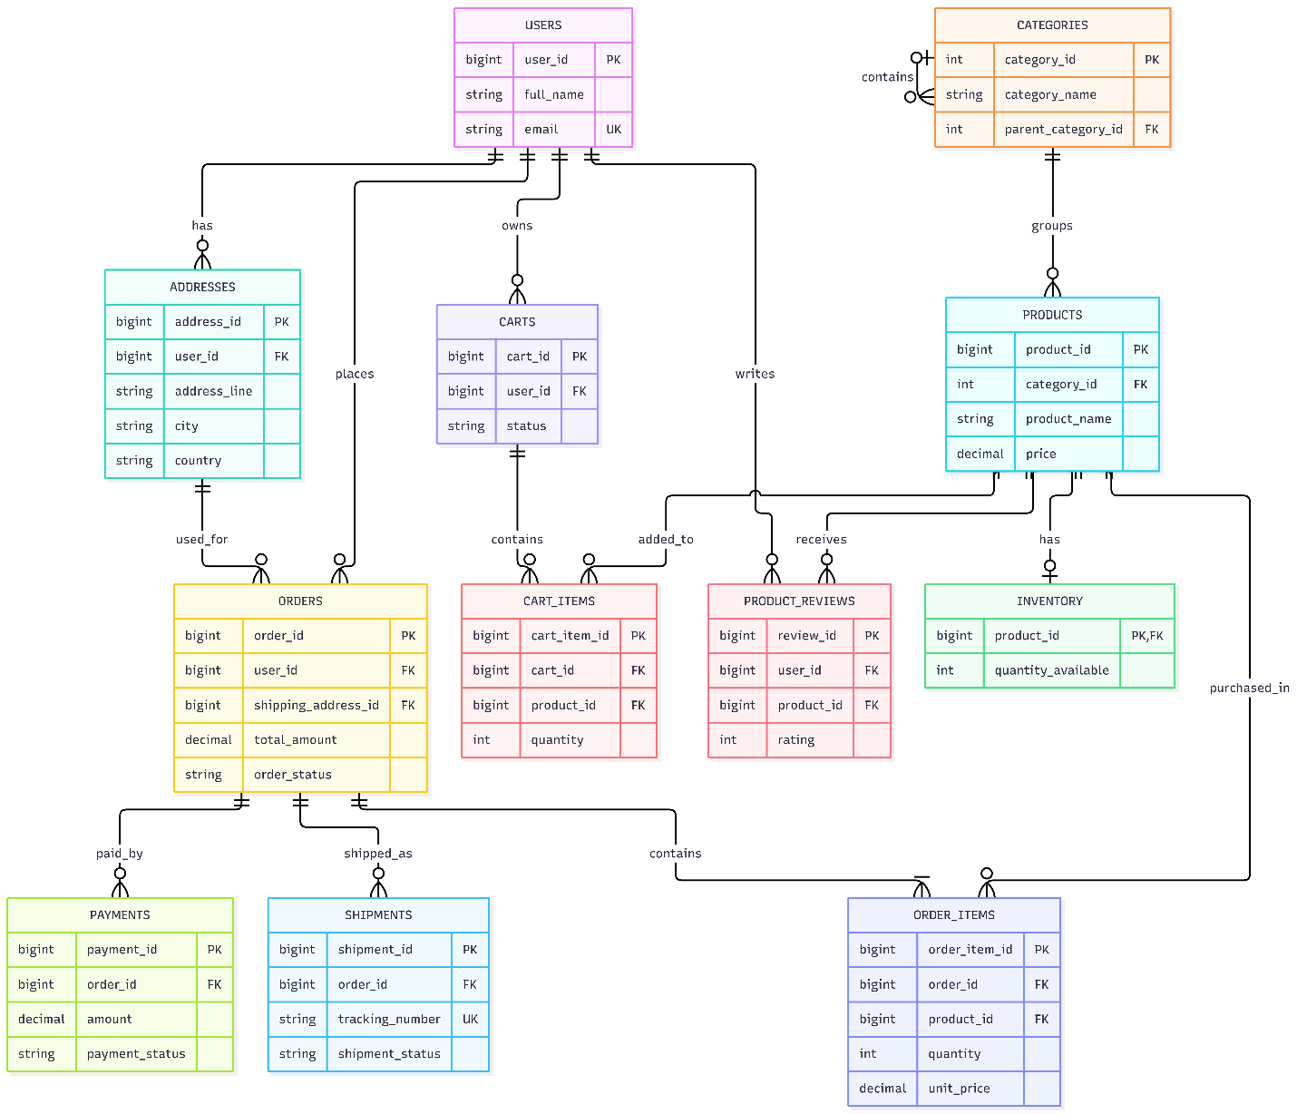
Main relationships
- One user can have multiple addresses, carts, and orders.
- One category can contain multiple products and subcategories.
- One cart can contain multiple products through Cart_Items.
- One order contains multiple order items.
- One order can have multiple payment attempts and shipments.
- One payment can have multiple refund records.
- One shipment can have multiple tracking events.
- One user can raise multiple support tickets and start multiple live chats.
- One product can have multiple images and reviews.
- Users and roles have a many-to-many relationship through User_Roles.

